**AWS IAM**

AWS Identity and Access Management (IAM) enables you to manage access to AWS services and resources securely. Using IAM, you can create and manage AWS users and groups, and use permissions to allow and deny their access to AWS resources.

Go to AWS Console and search “IAM” on it.

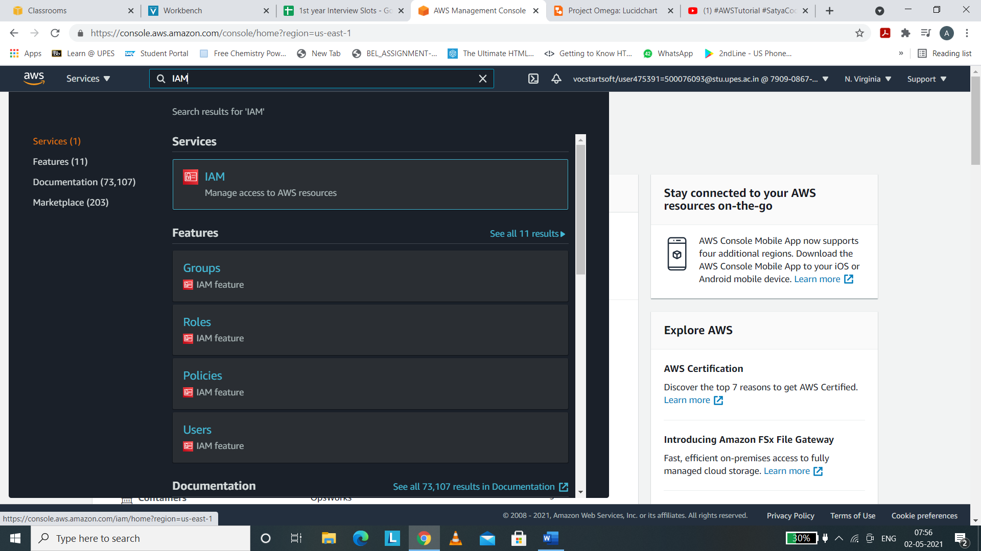

On clicking IAM , we will be navigated to the Dashboard of IAM. On the left navigation panel , there are access management options like users, user groups, roles, policies etc. , access reports , and other options too.

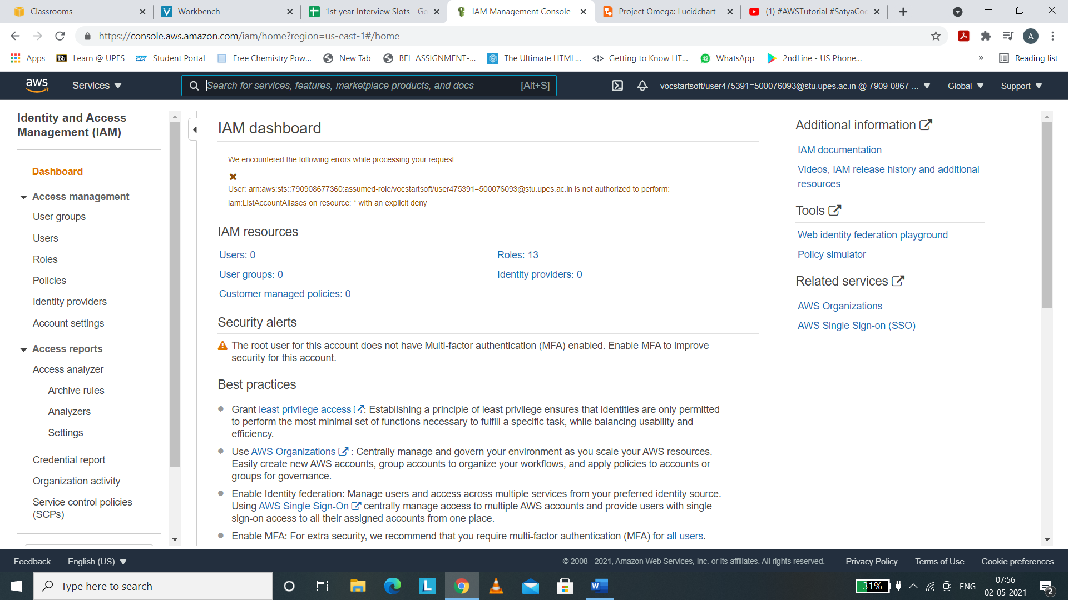

ADDING USERS

(i) Navigate to users option in the left navigation panel of AWS IAM Dashboard.

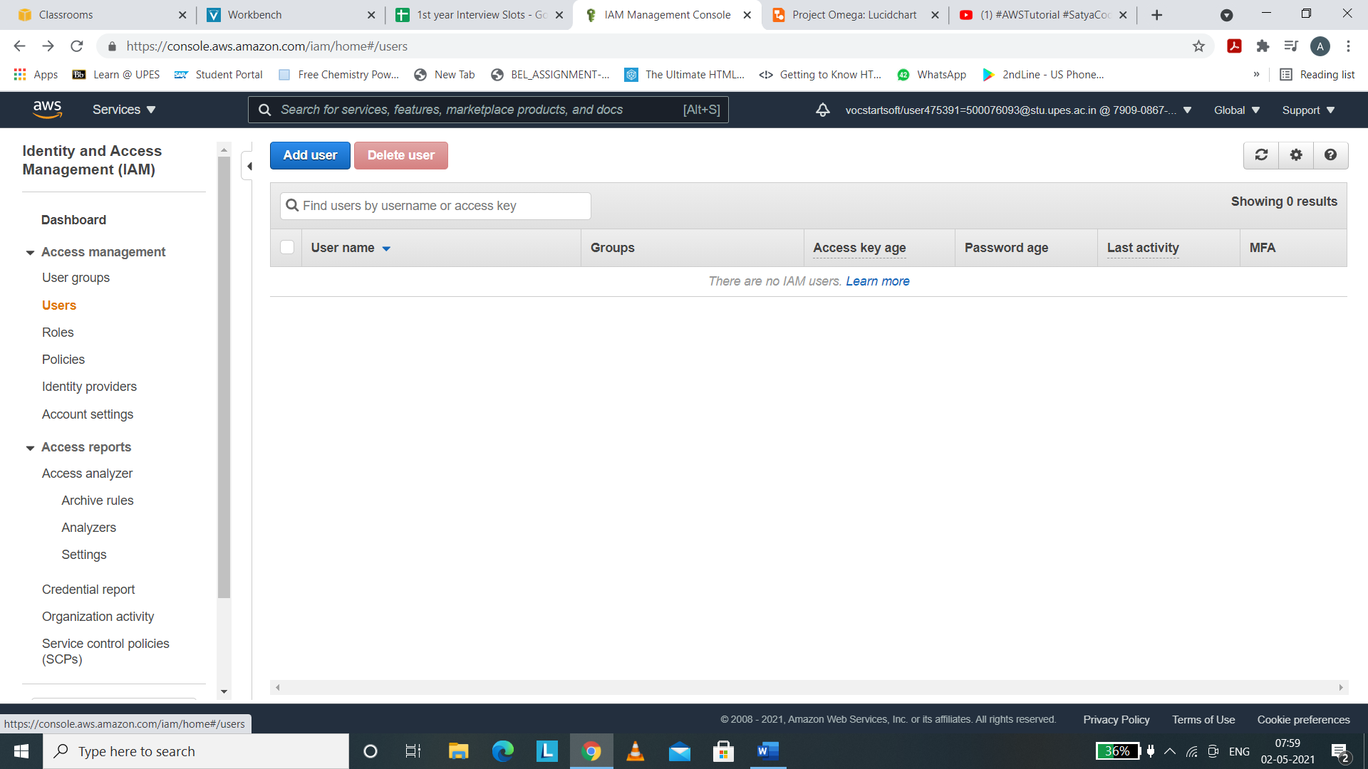

(ii) For adding users, click on the “Add User” button.

(iii) We have to set user details like username , access type like password, permissions etc.

(iv) Set username , we may add another users by clicking on “Add another user” button.

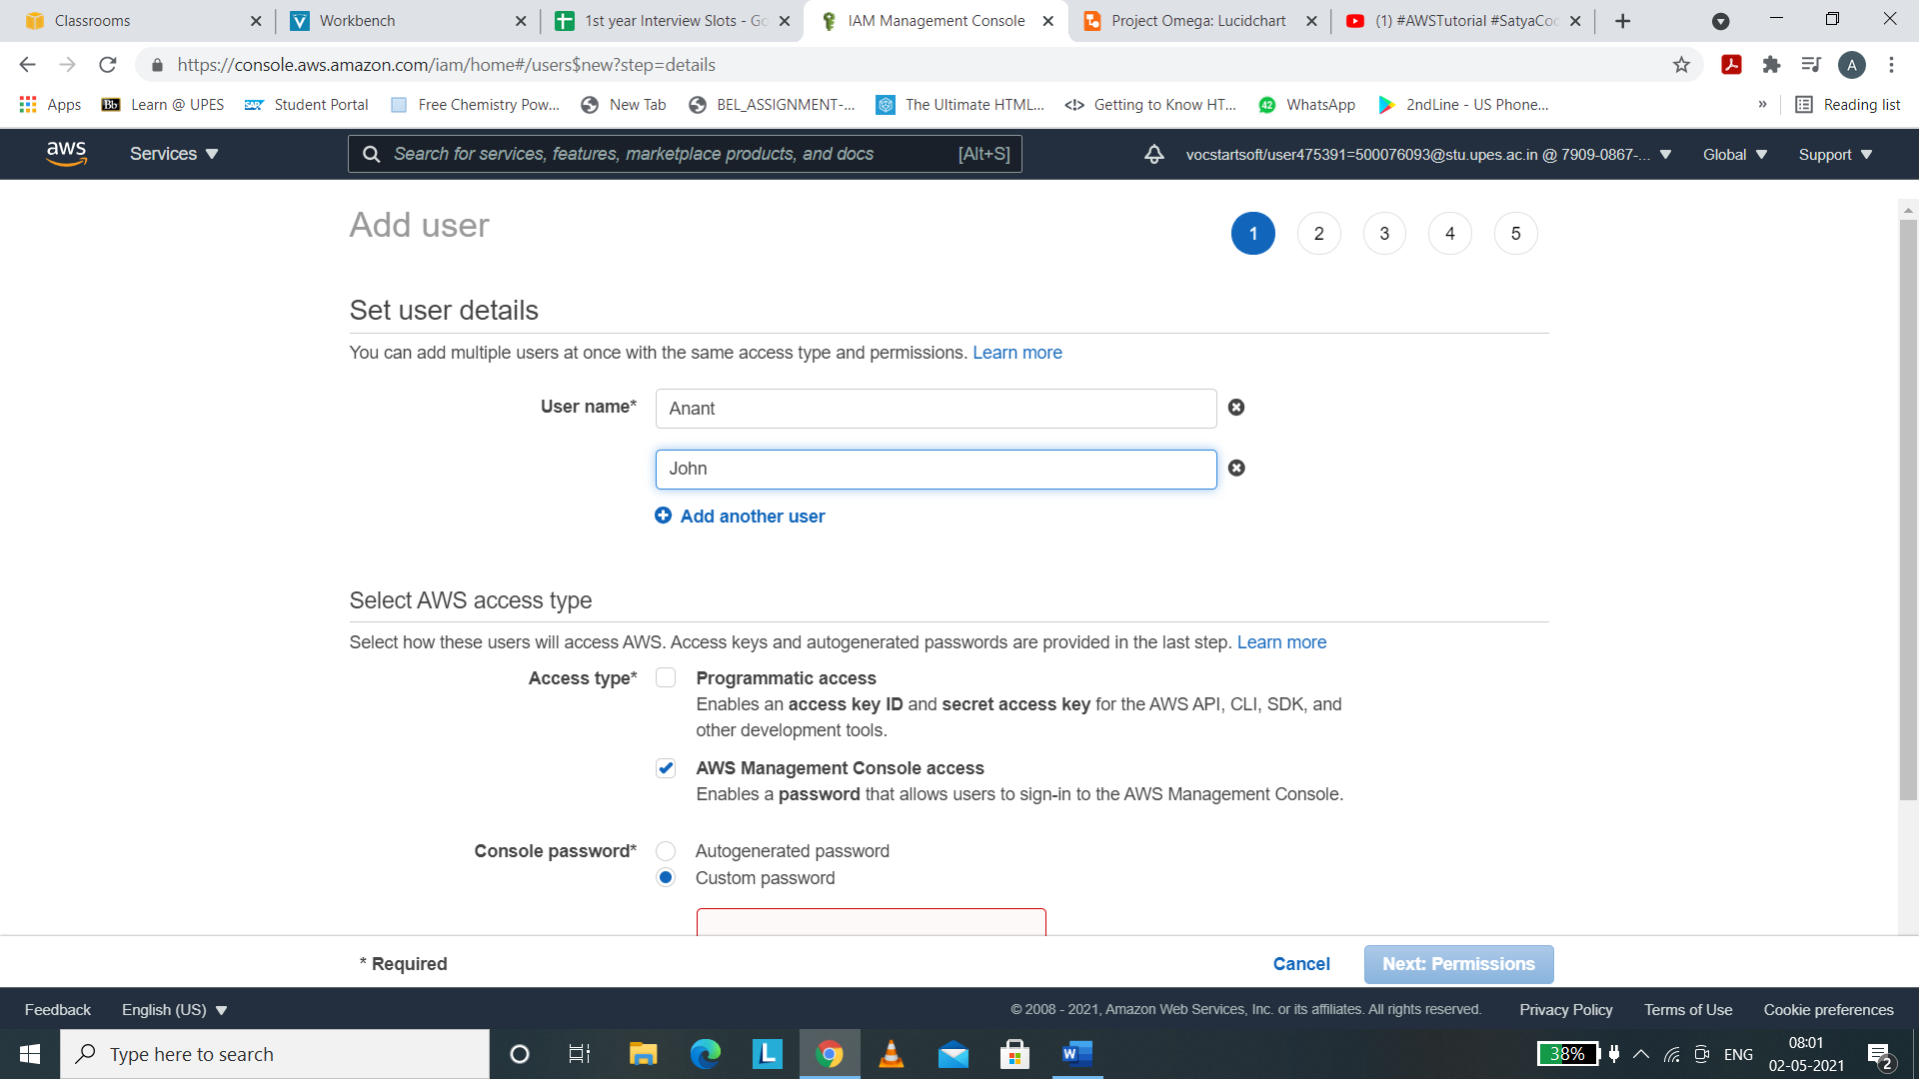

(v) Select AWS access type. Click on AWS Management Console in order to login through console. Then choose console password either autogenerated or custom. We can have an autogenerated password from AWS itself.

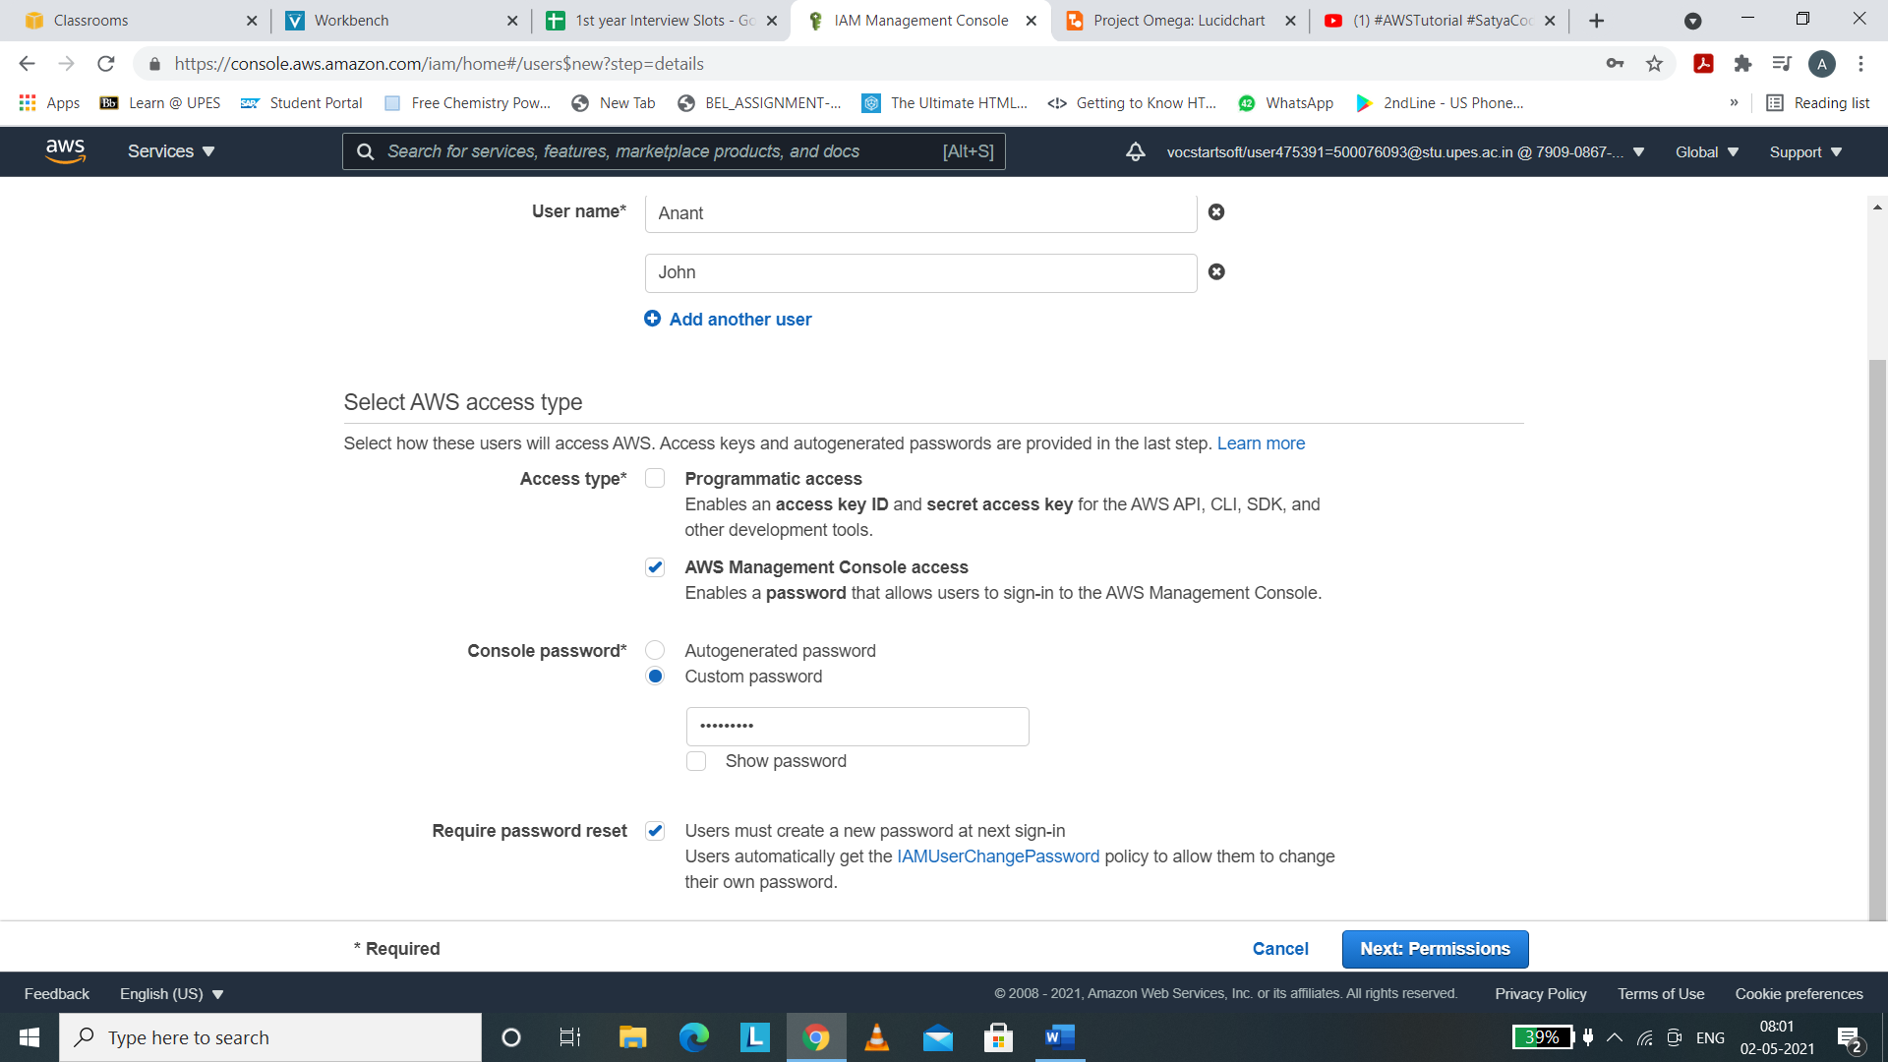

(vi) Click on Next:Permissions and this option will allow us to attach permissions to your users like adding users to group or copy permissions or attaching existing policies.

As we want to attach policy to our user, click on Attach existing policies.

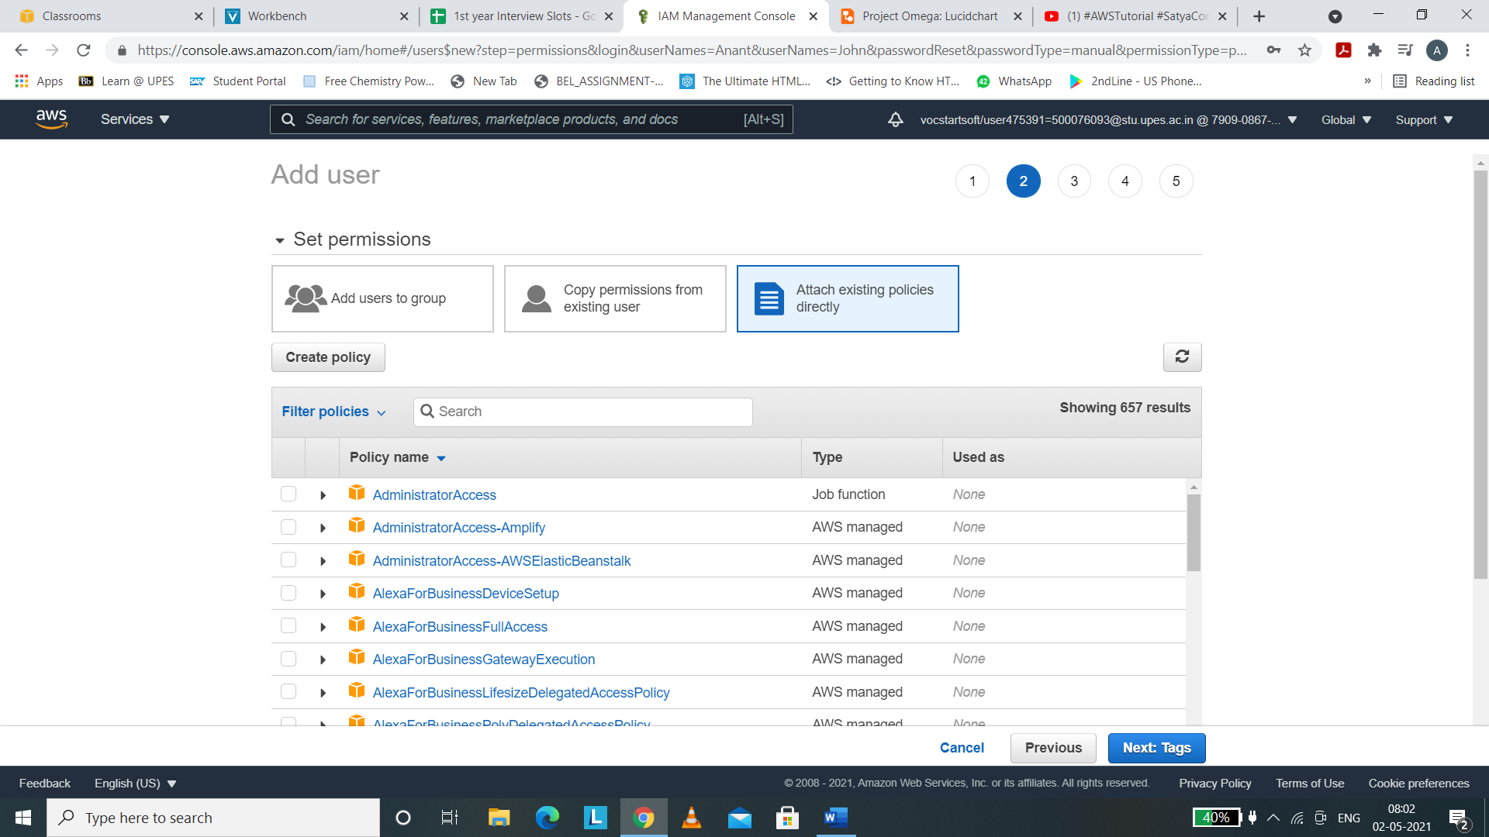

(vii) I wish to choose my users to have administrator access , therefore I am clicking on Administrator Access

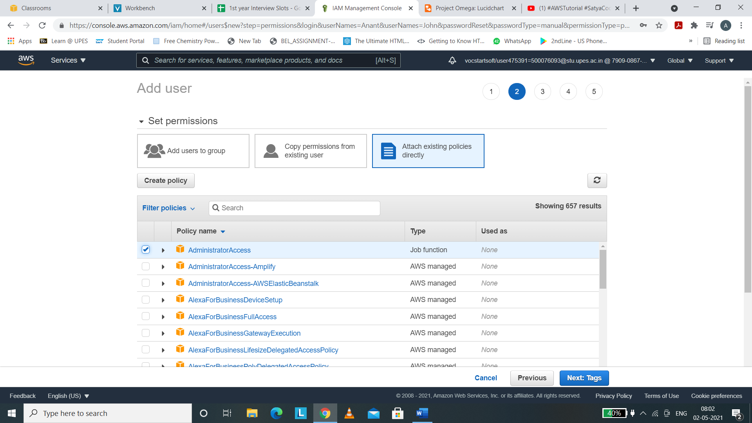

(viii) We can associate tags with our user. This is an optional thing.

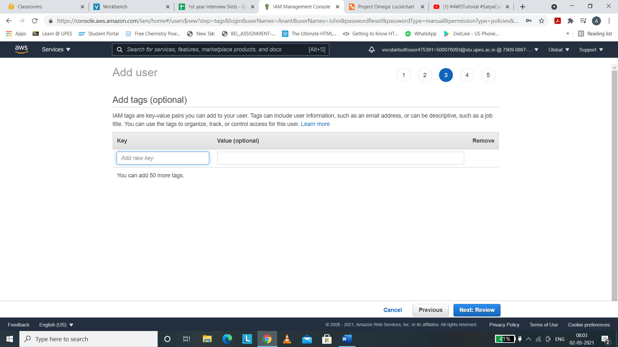

(viii) Review the user and click on create users.

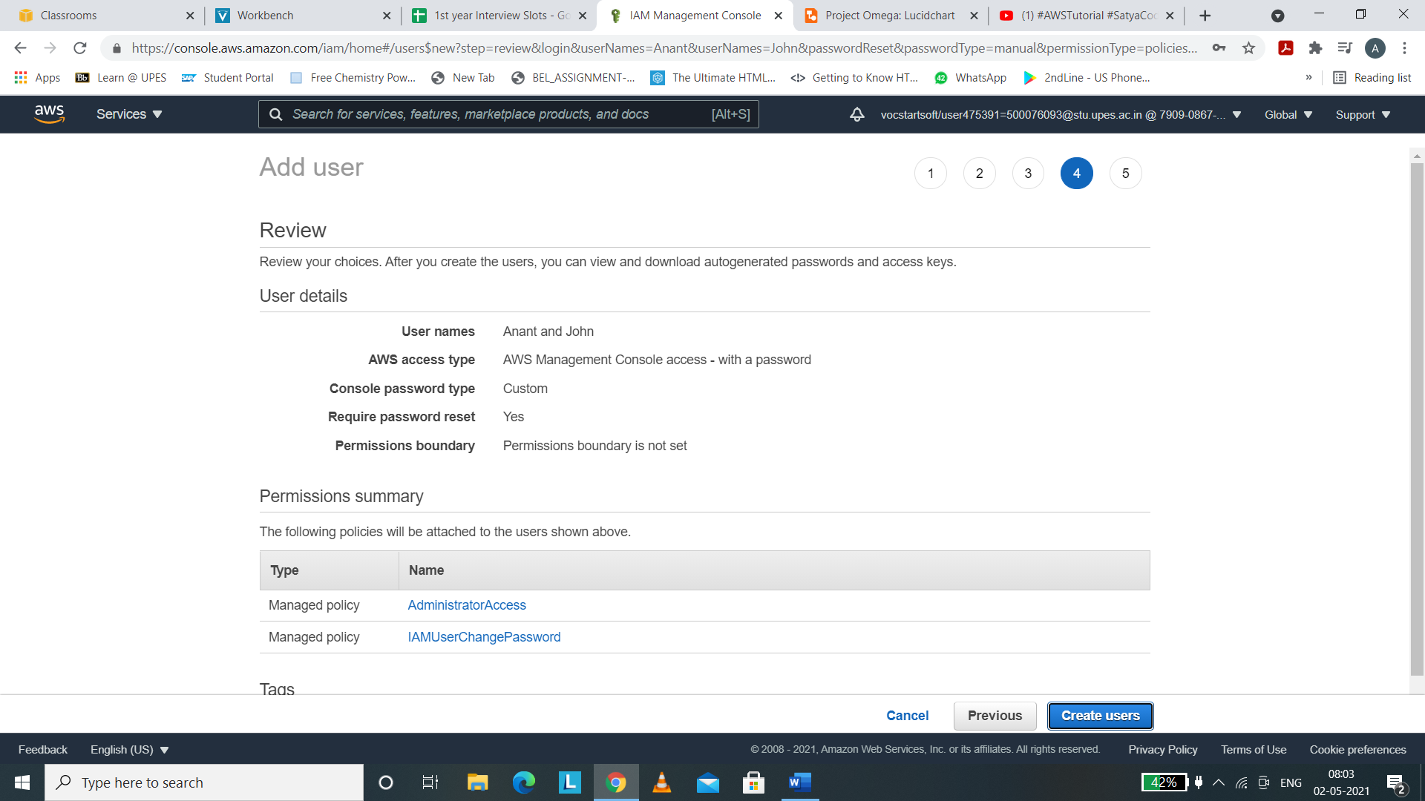

(ix) Users will be created with error because AWS Educate does not support making login profiles for the user.

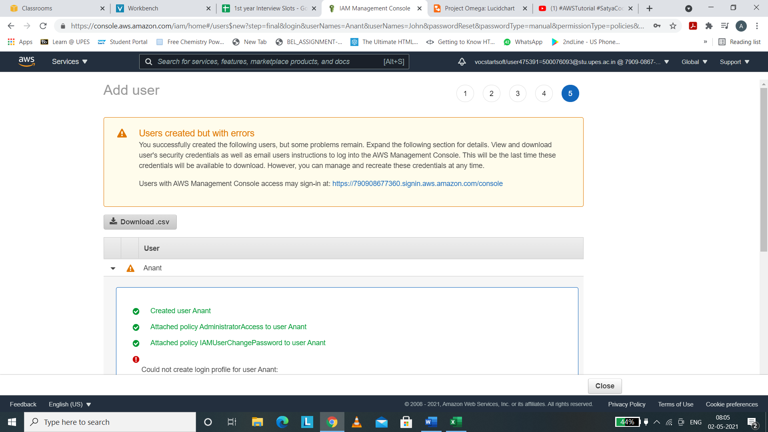

(x) Download the .csv file for the credentials of your user.

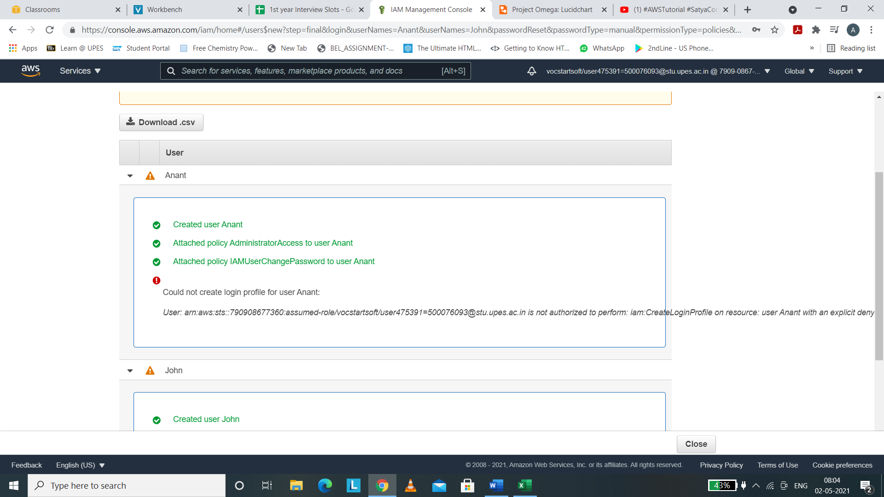

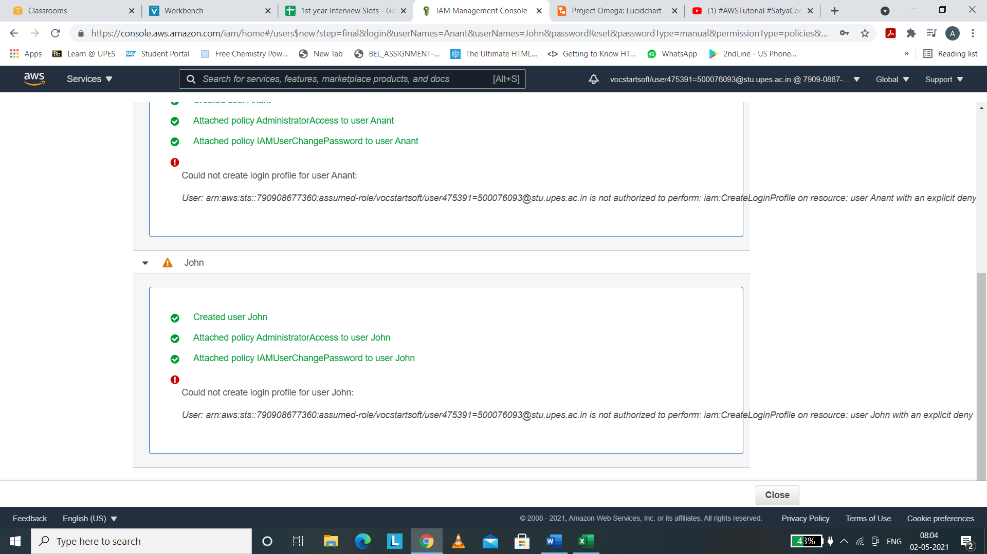

ADDING GROUPS

(i) Click on User Groups on the left navigation panel of the IAM Dashboard. We can see the panel of user groups. Currently there are no groups and therefore is empty.

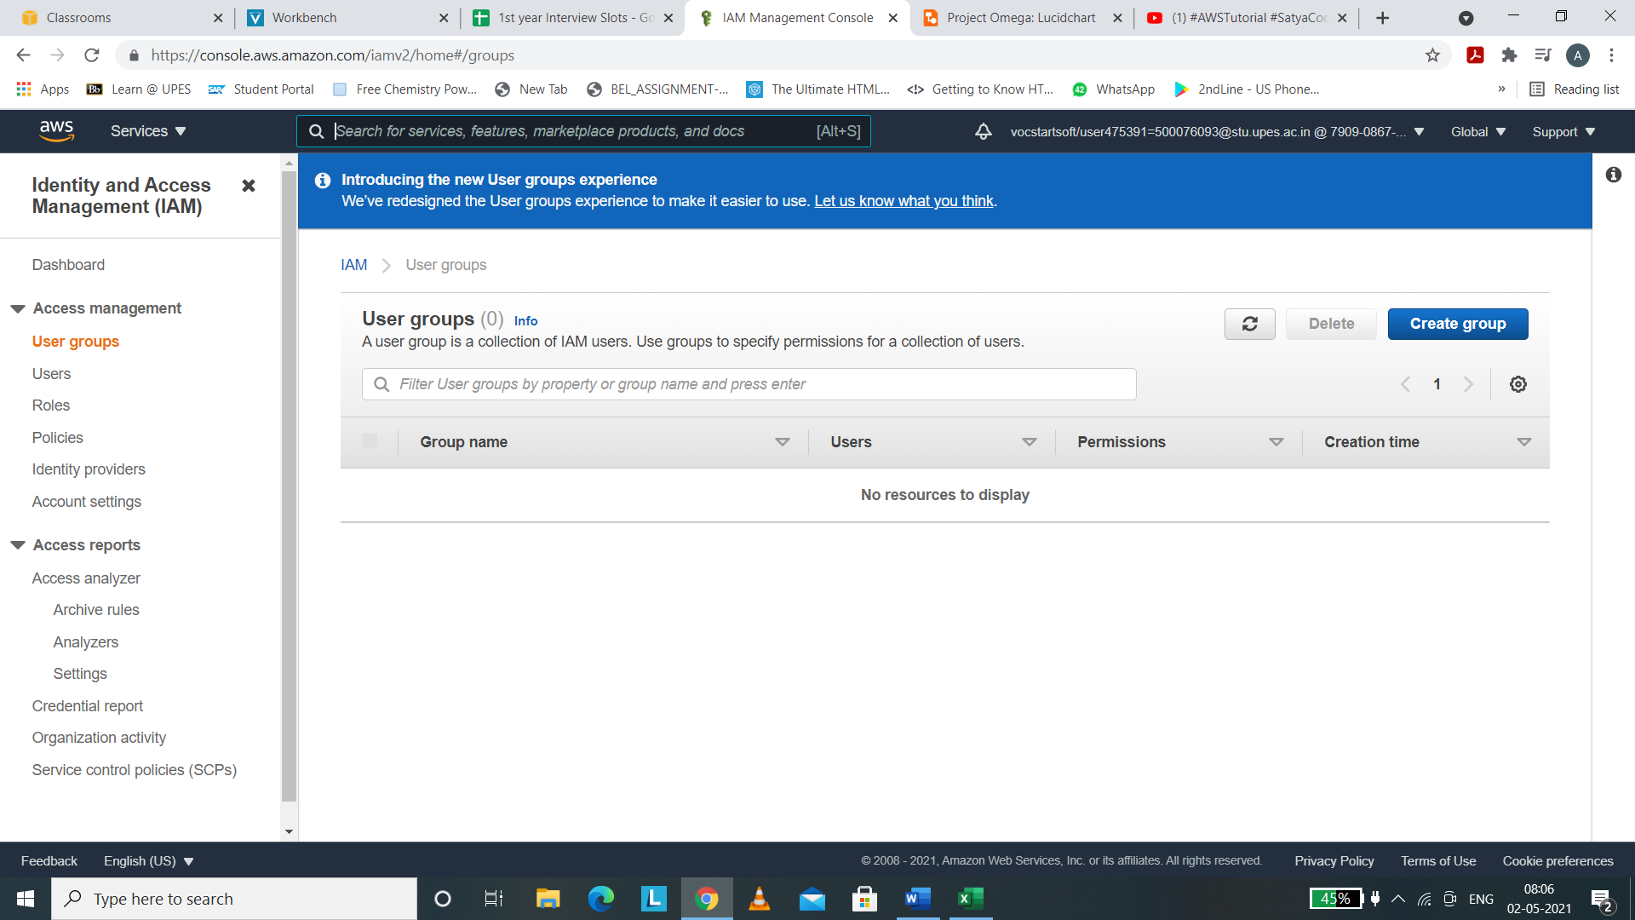

(ii) For creating group , click on “Create group” button.

(iii) Now, change the name of the group as per your wish.

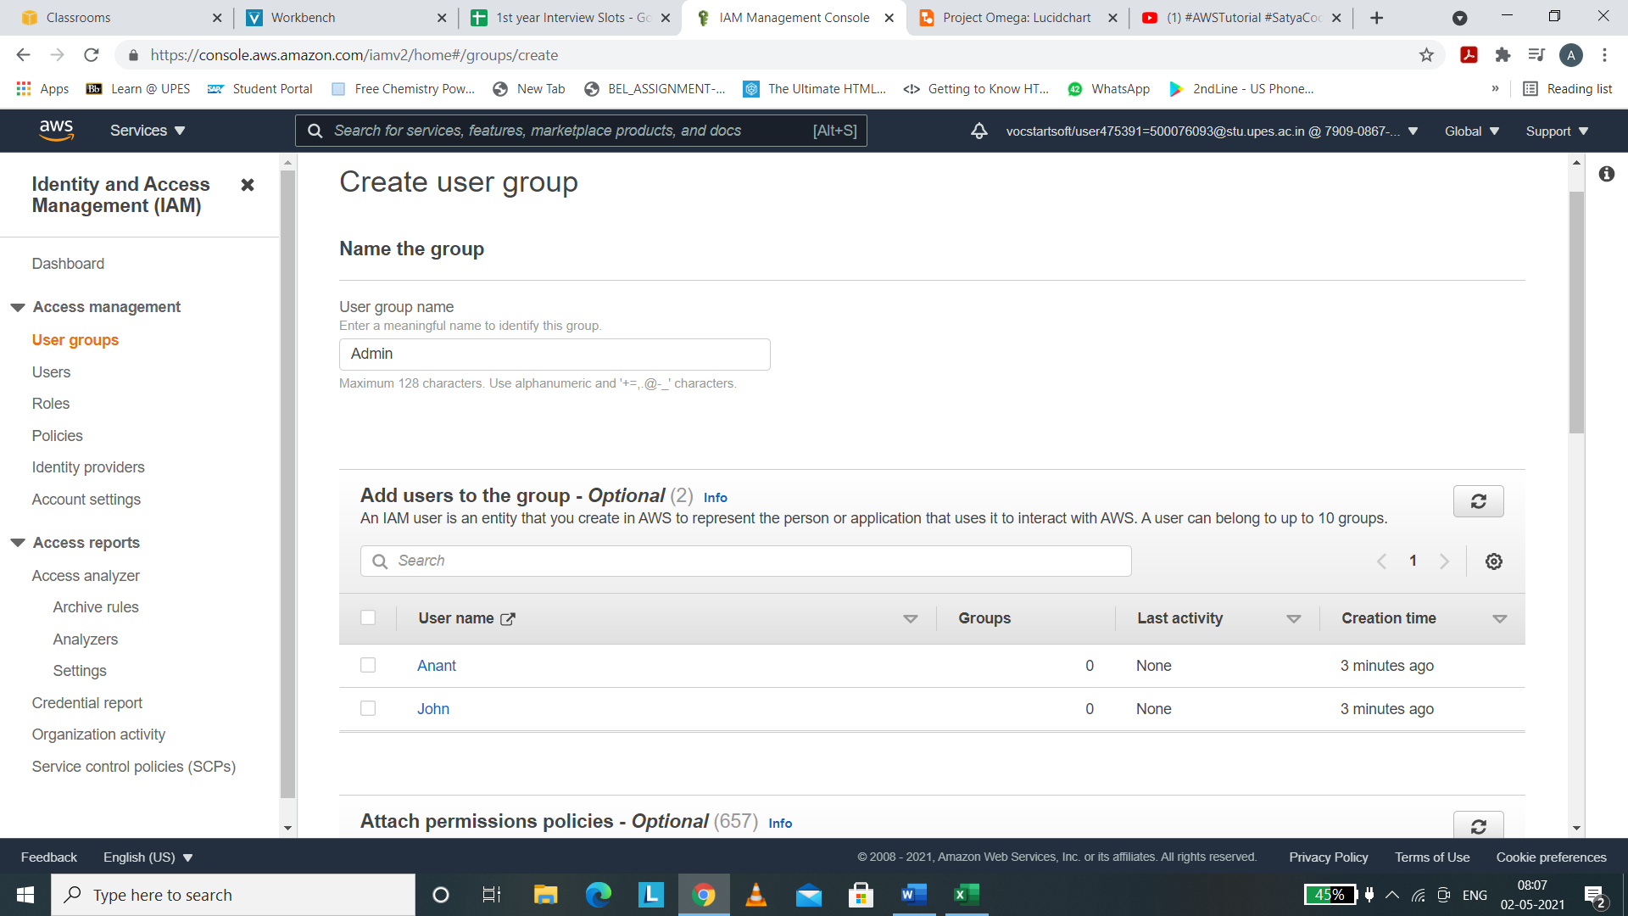

(iv) The user group itself can have certain permissions that only the users within this group can use.

I am giving this group the Administrator access i.e the users within this group will get all the powers that a administrator enjoys.

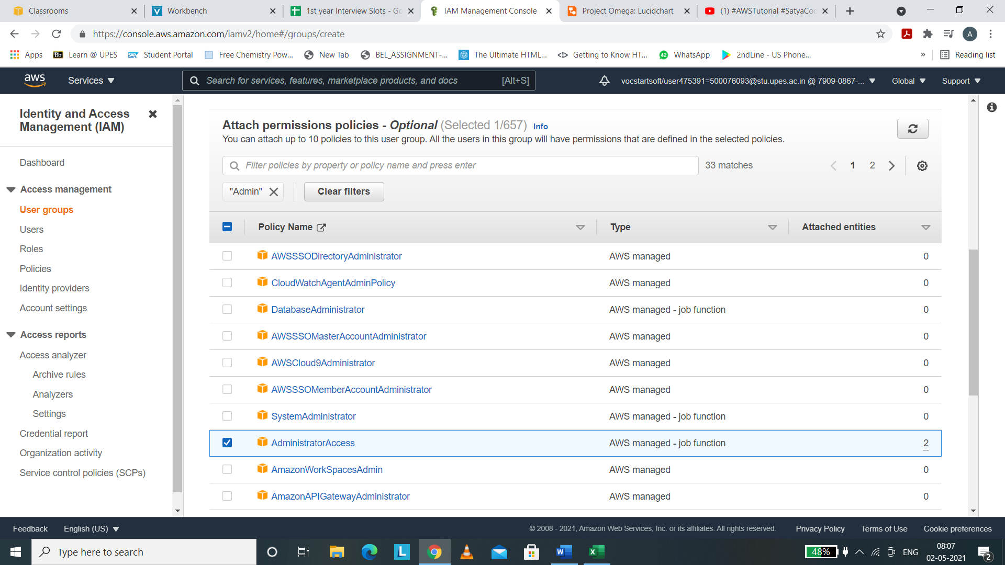

(v) In this way , the group is created and we can see the group on the panel.

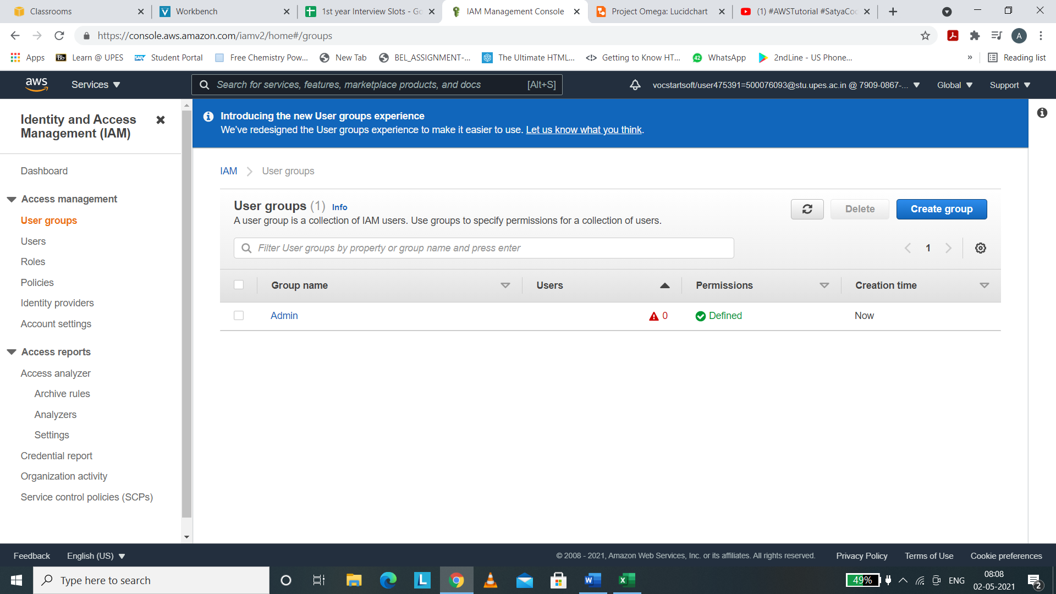

We can change the Password policy by tapping on Account Settings button in the left navigation panel of IAM and we will be redirected to the screen below.

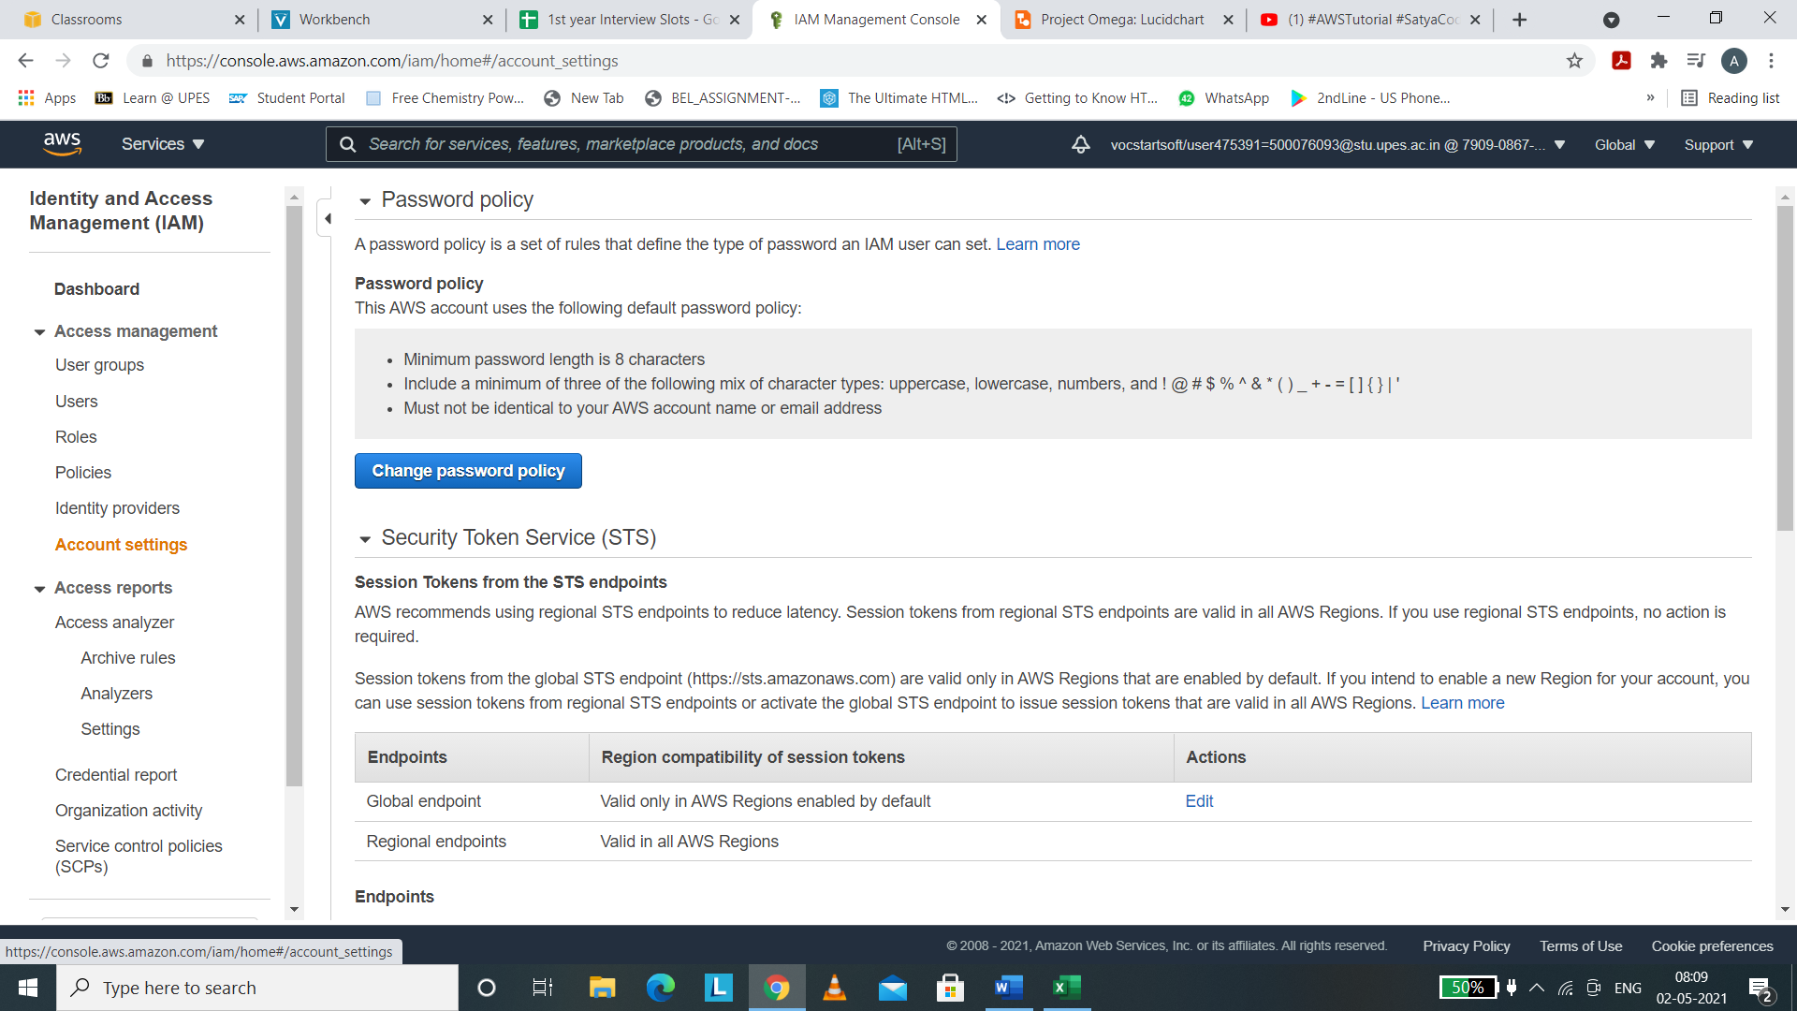

Click on Change Password Policy.

Set the password policies, when we want the password to expire or when we need to prevent the password reuse.

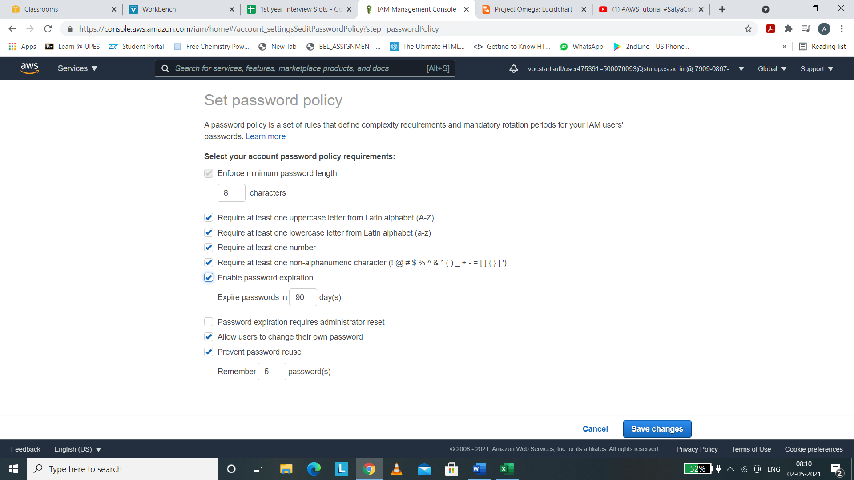

Hence in this way the password policy is changed.

GROUPS AND POLICIES

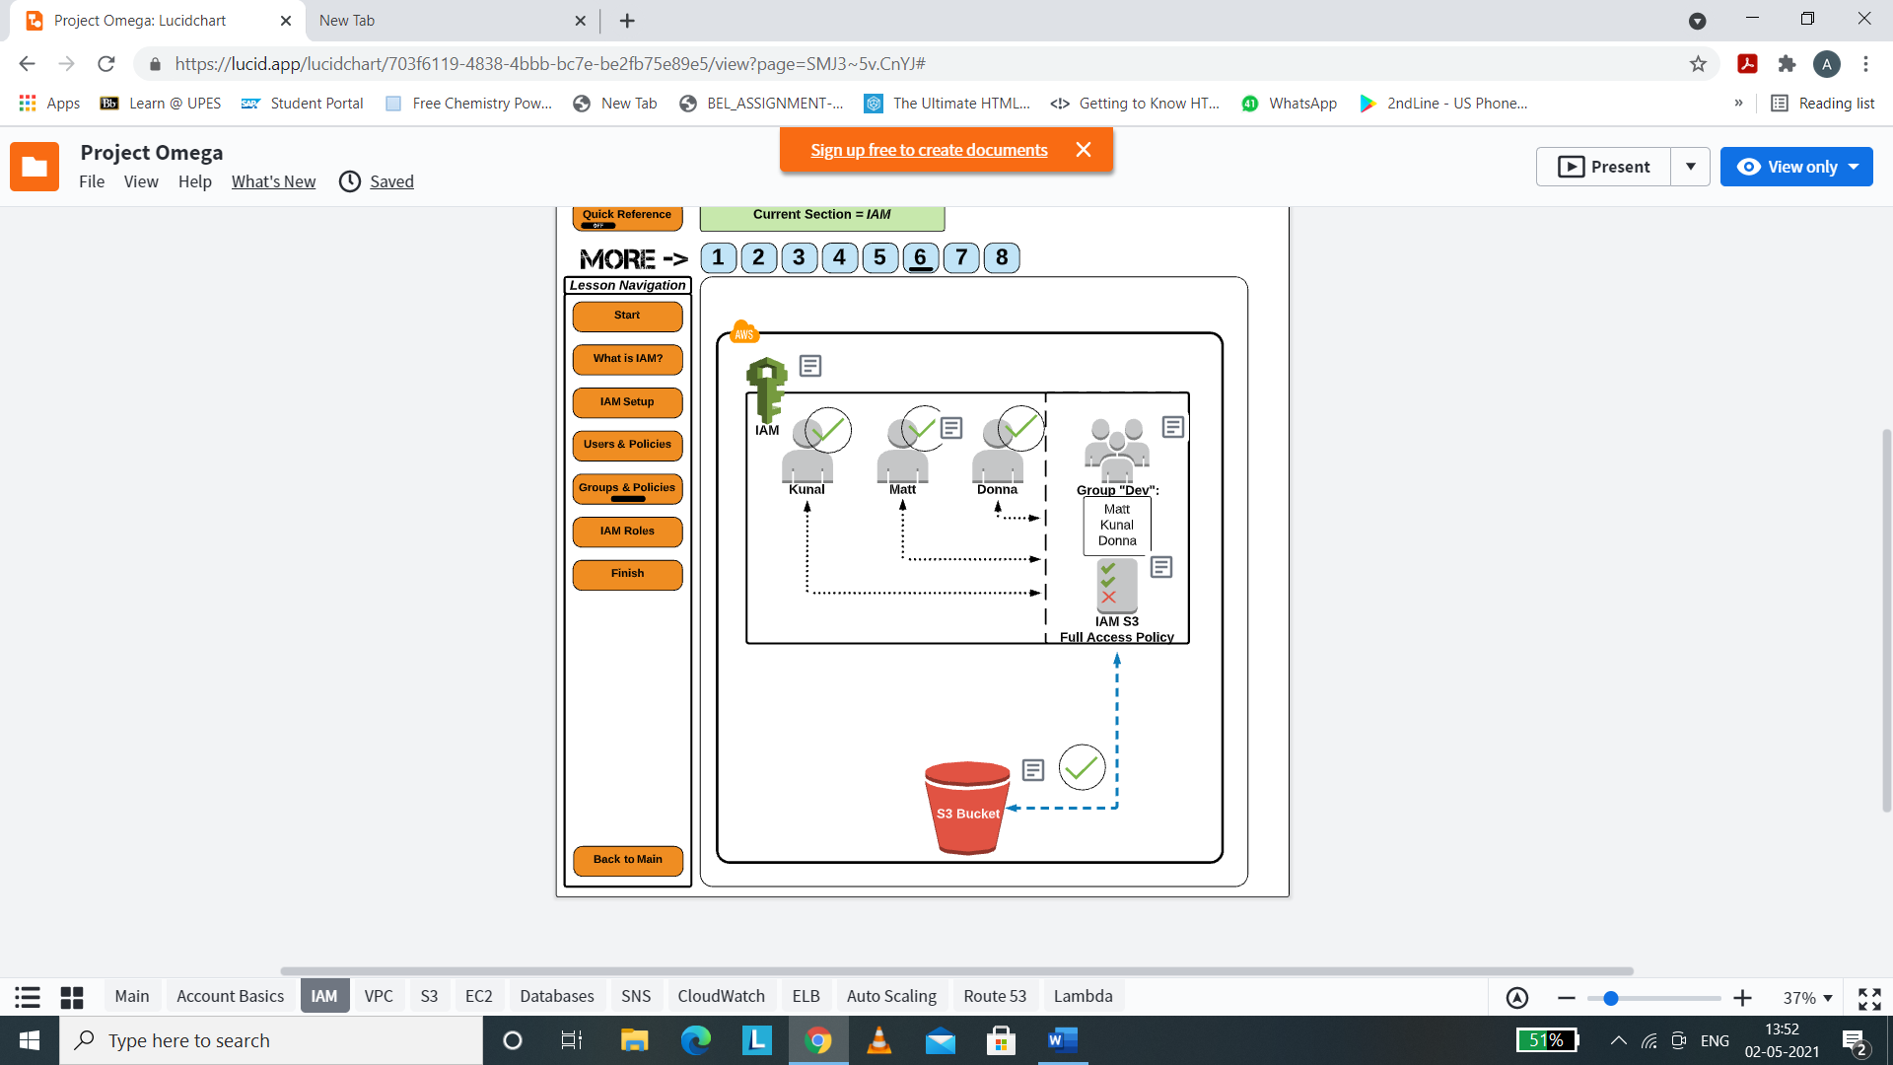

Suppose we have some users who wants S3 Full Access , so we will create a user group that contains the permission policy to access S3. If we want to give permission to each individual user , we are free to give that but it is quite a lengthy task.

We will be making a user group that have the users and the access to full S3 bucket.

(i) Name the user group , for e.g. Dev.

Add the users we have previously made i.e. Anant and John.

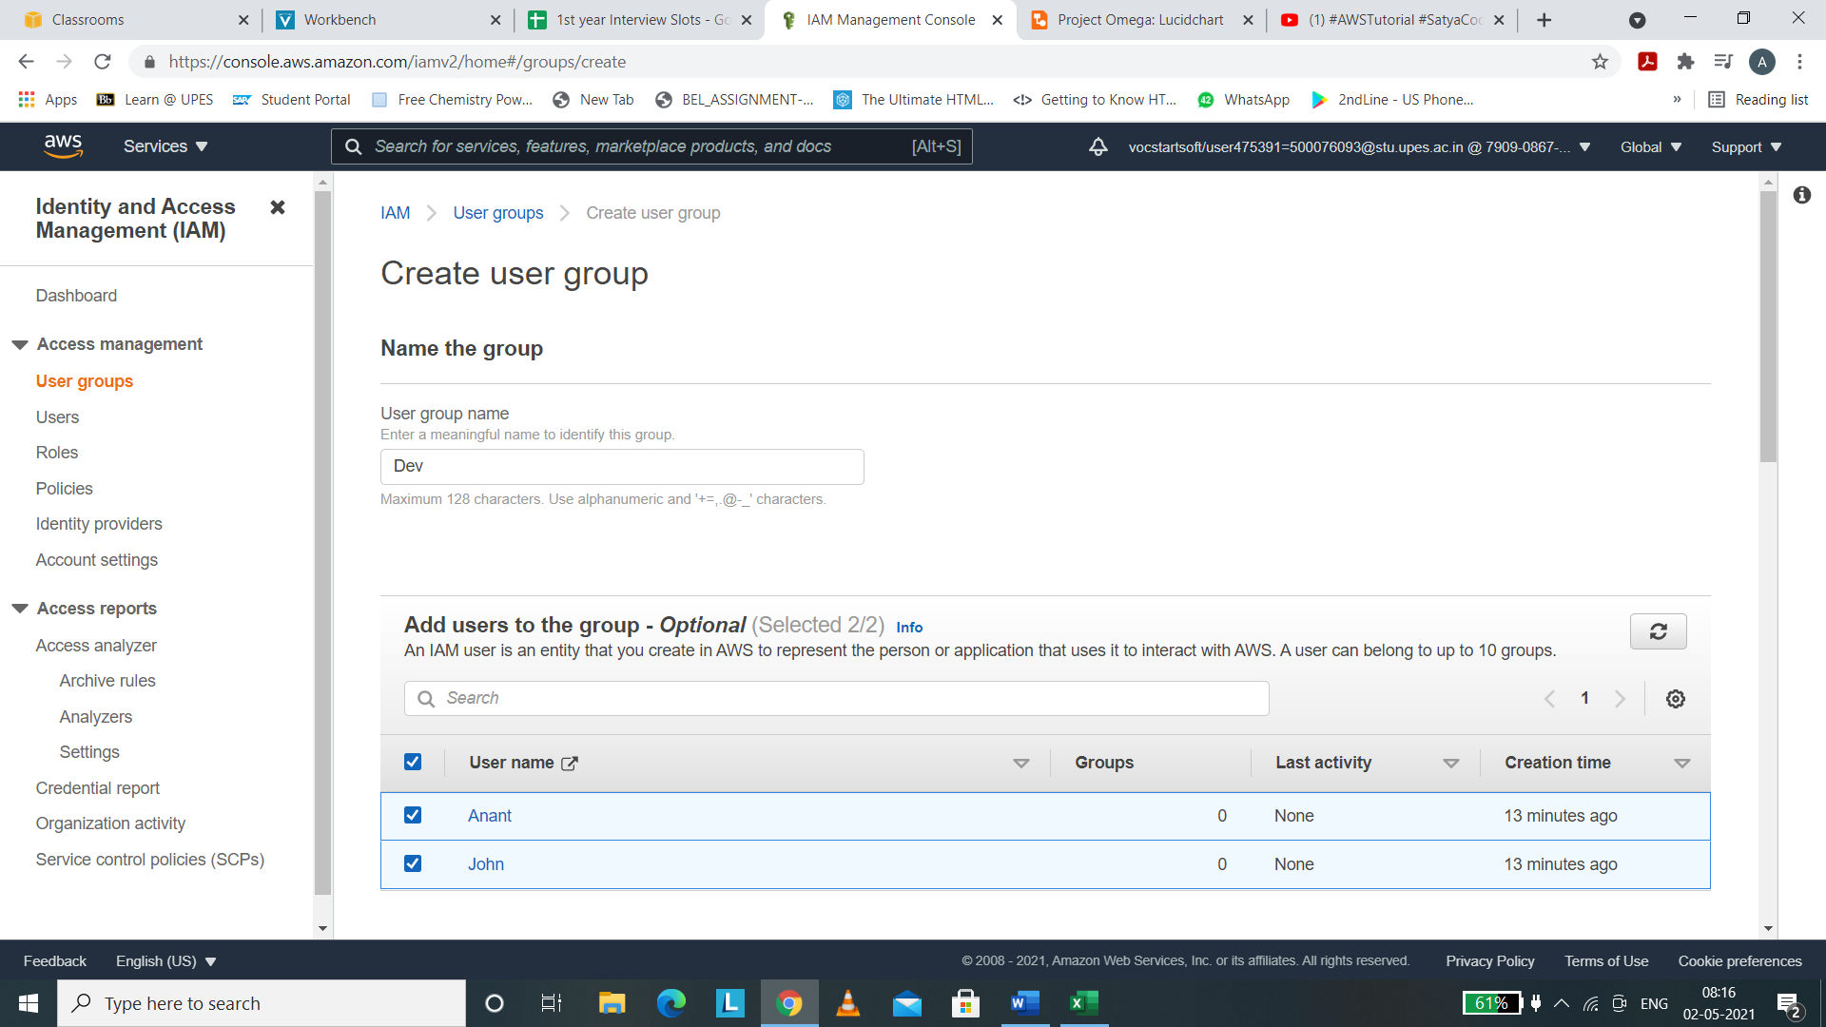

(ii) Attach the S3Full Access Permissions.

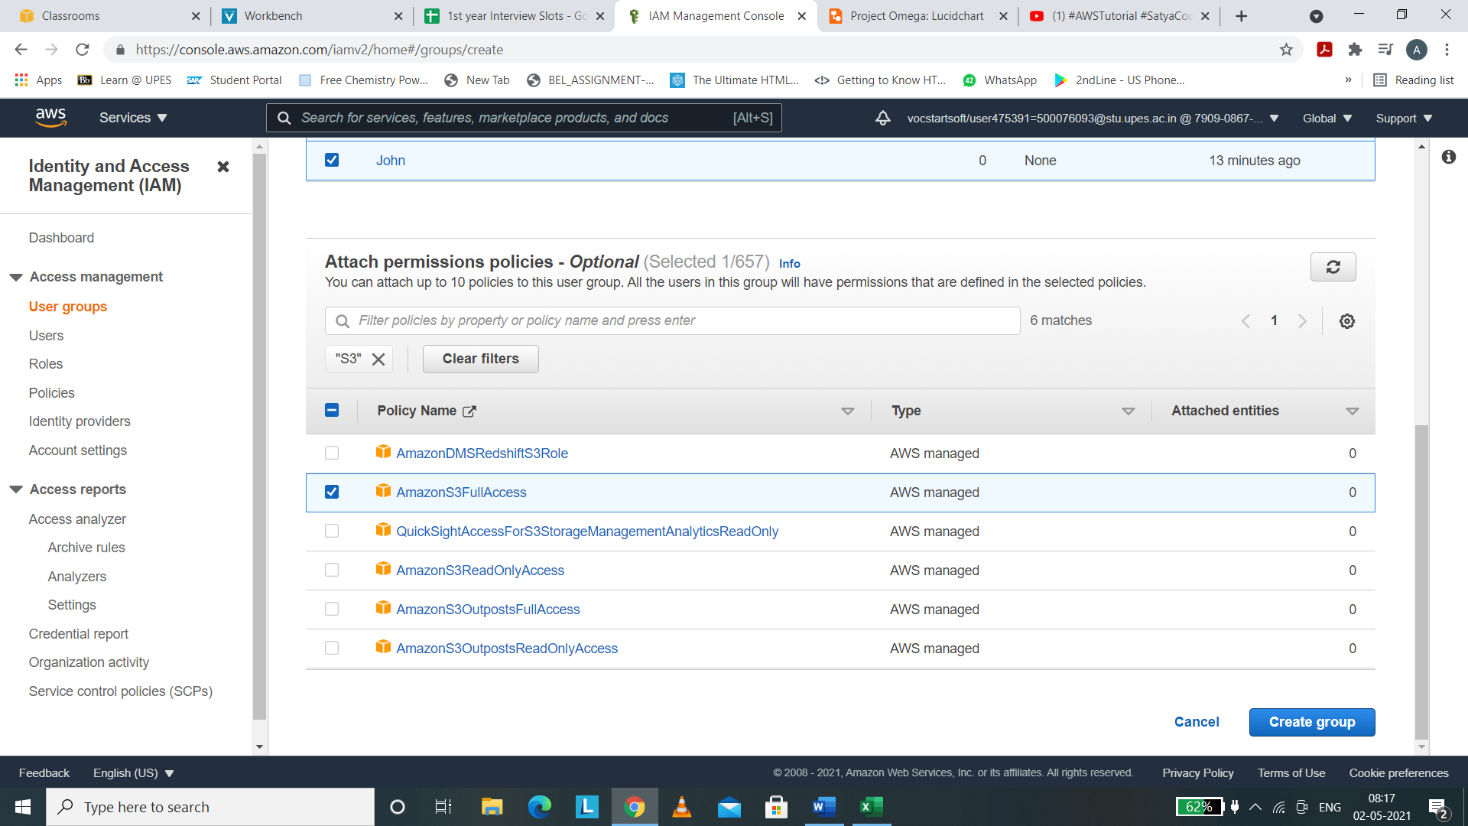

(iii) Click on “Create Group” button.

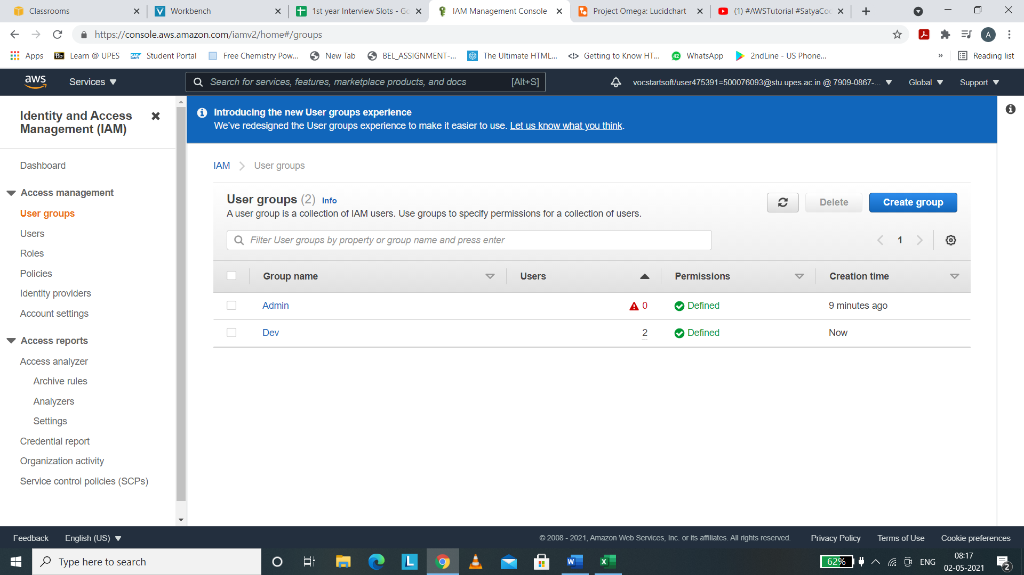

IAM ROLES

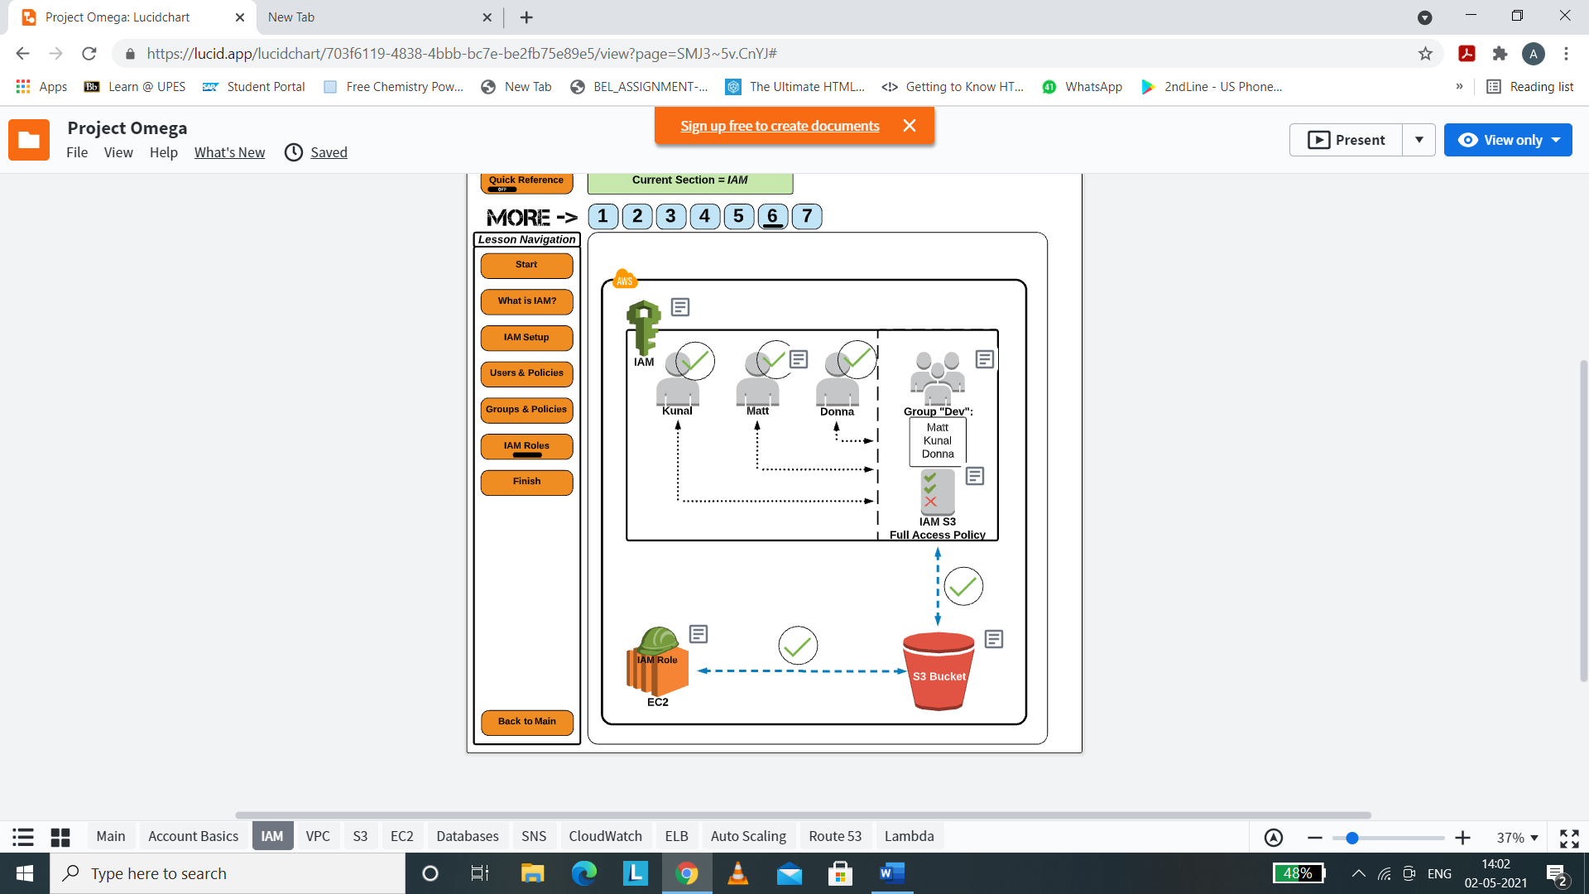

(i) Go to Roles in the left navigation panel of IAM Dashboard.

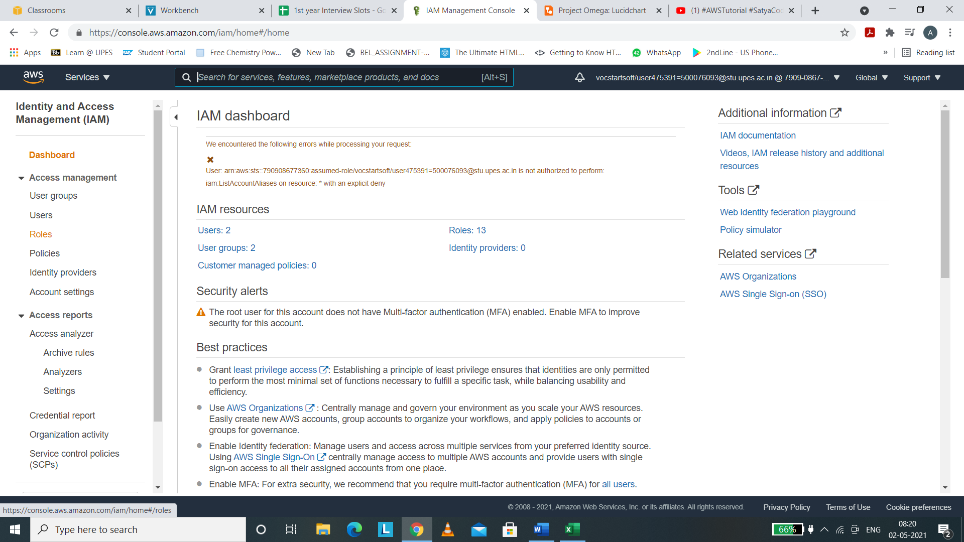

(ii) We will be redirected to IAM roles panel. Click on “Create Role”.

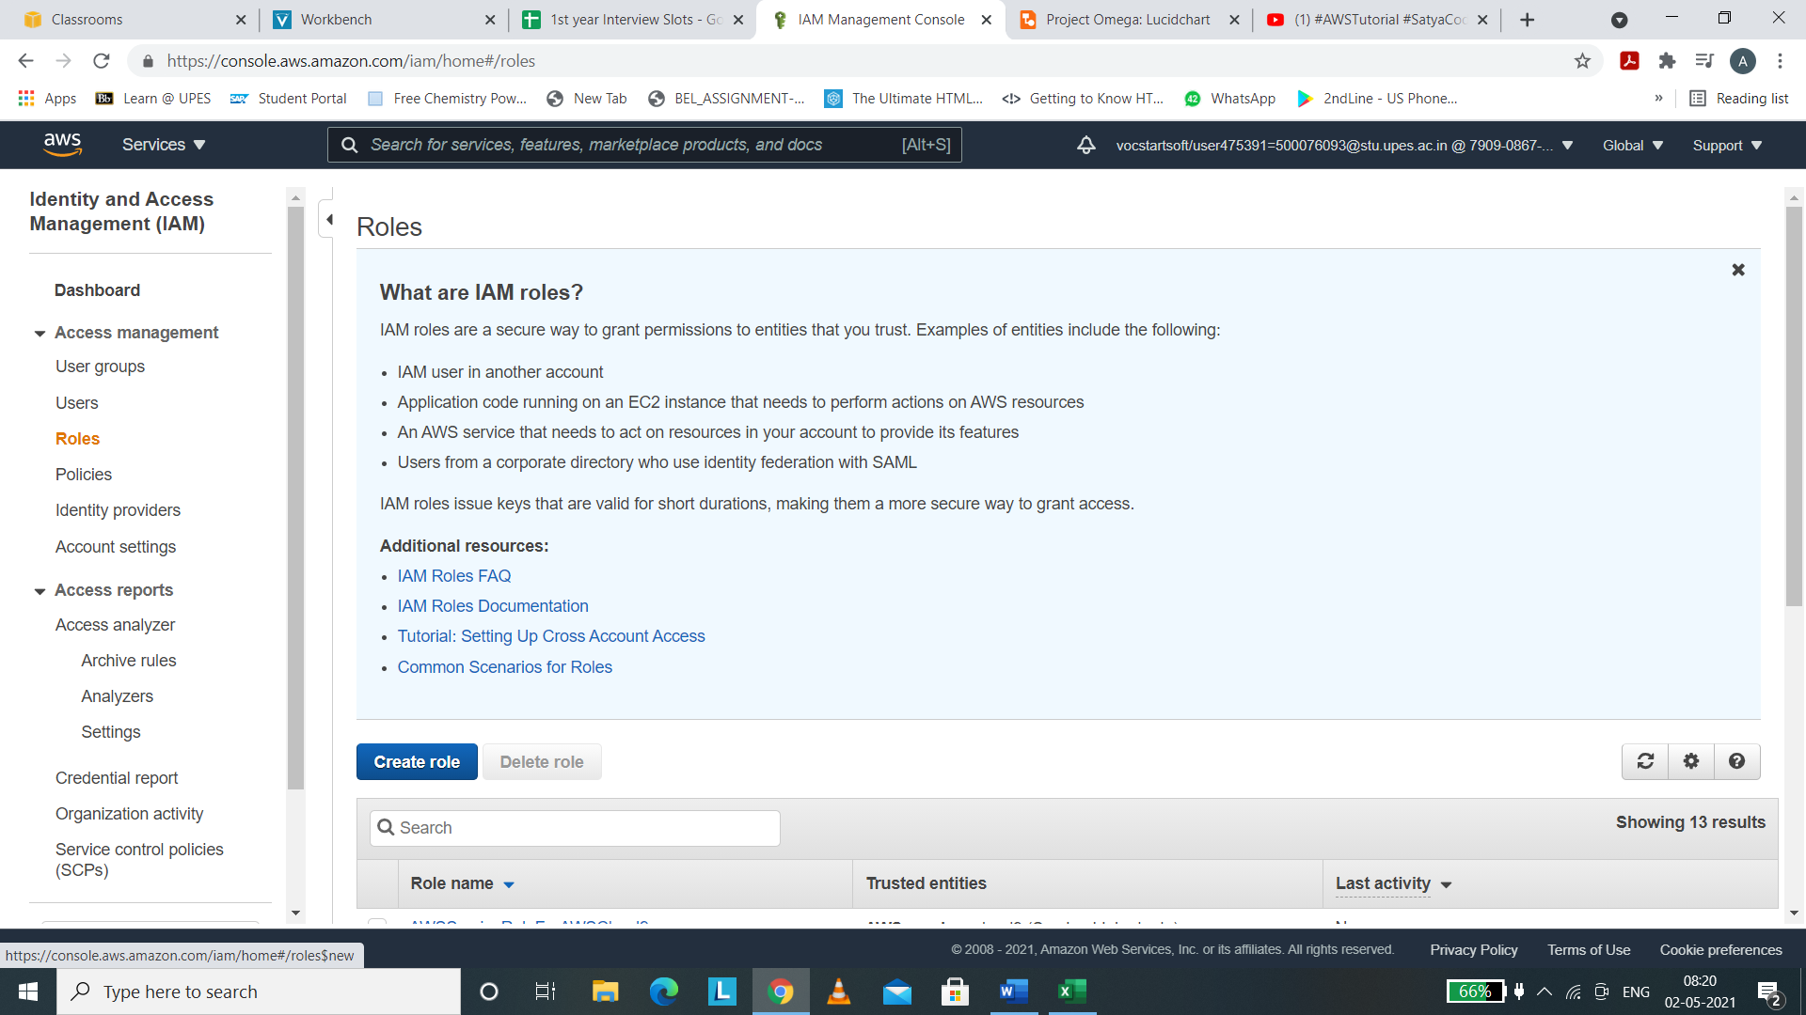

(iii) Our S3 bucket wishes to connect to AWS EC2. So we will be choosing trusted entity as AWS Services.

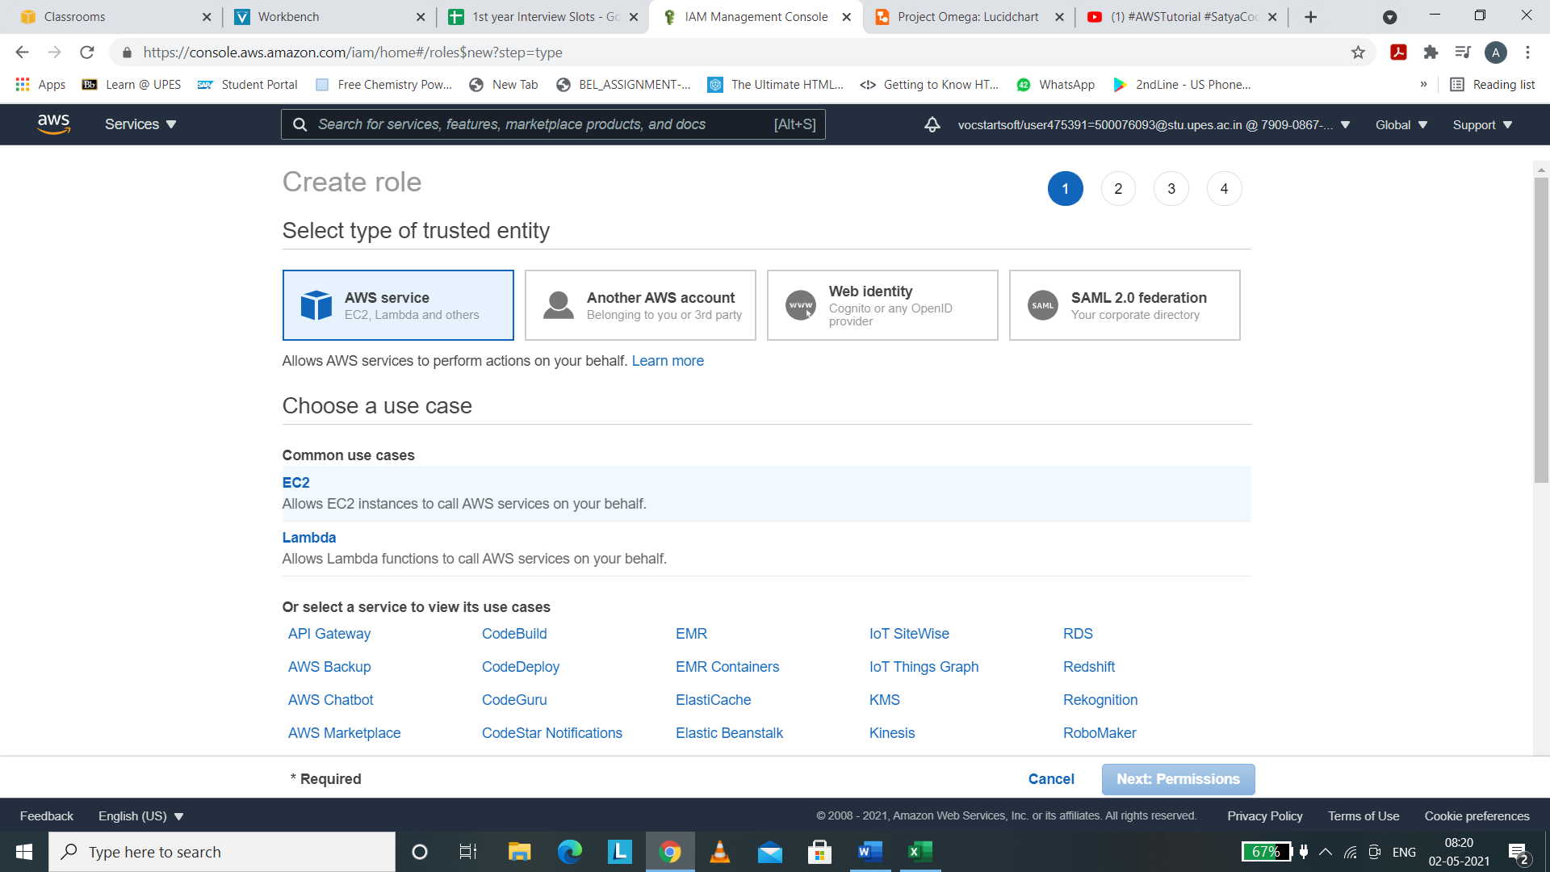

(iv) Add permissions like AmazonS3FullAccess

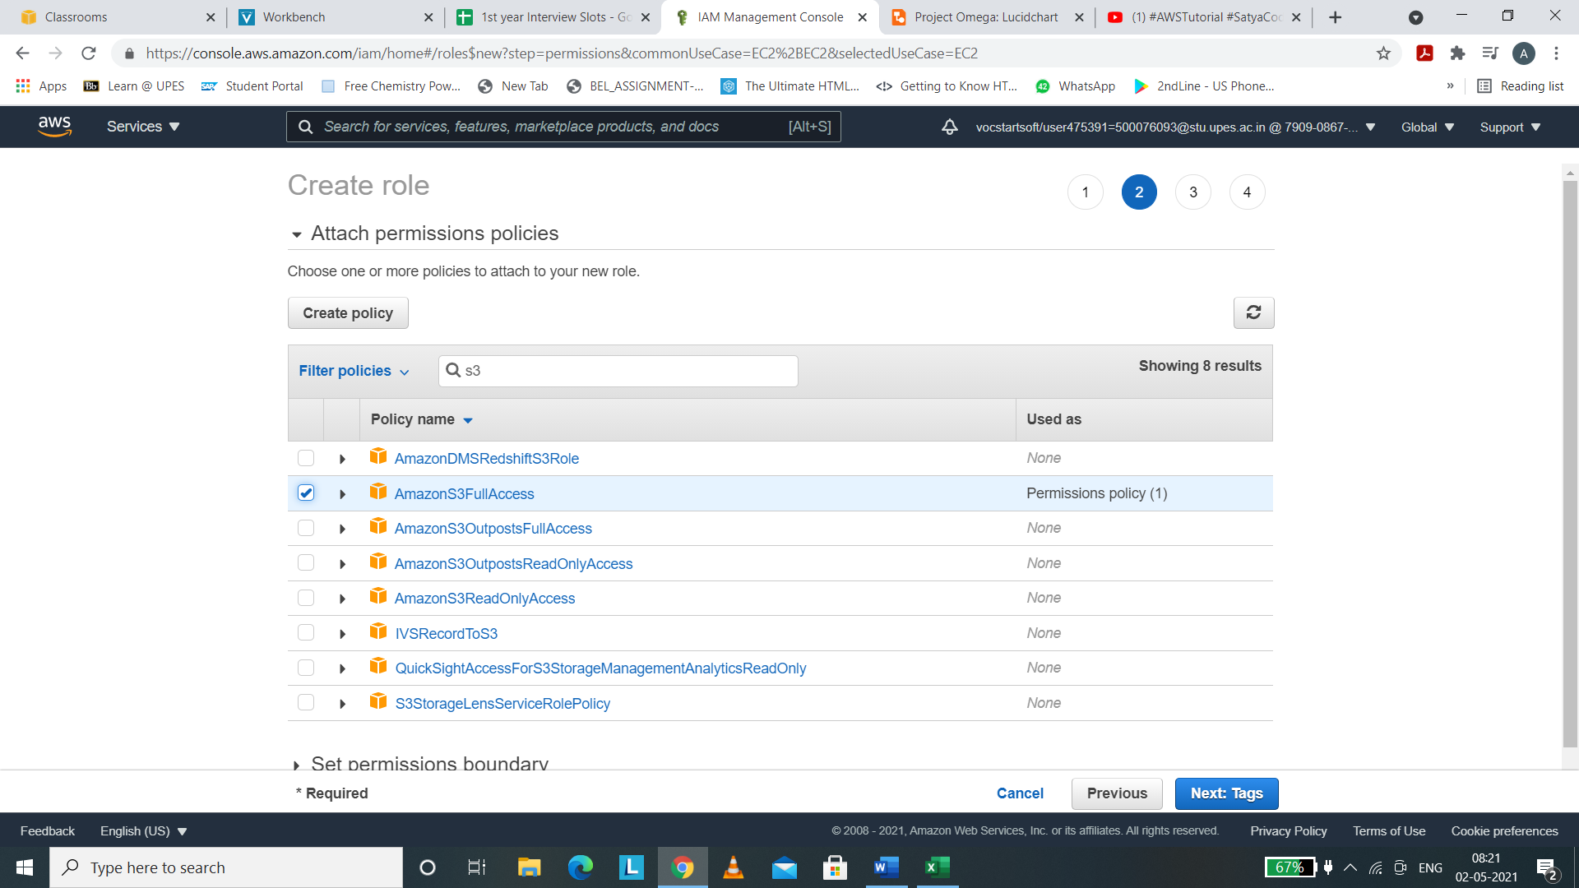

(v) Name the role and review it.

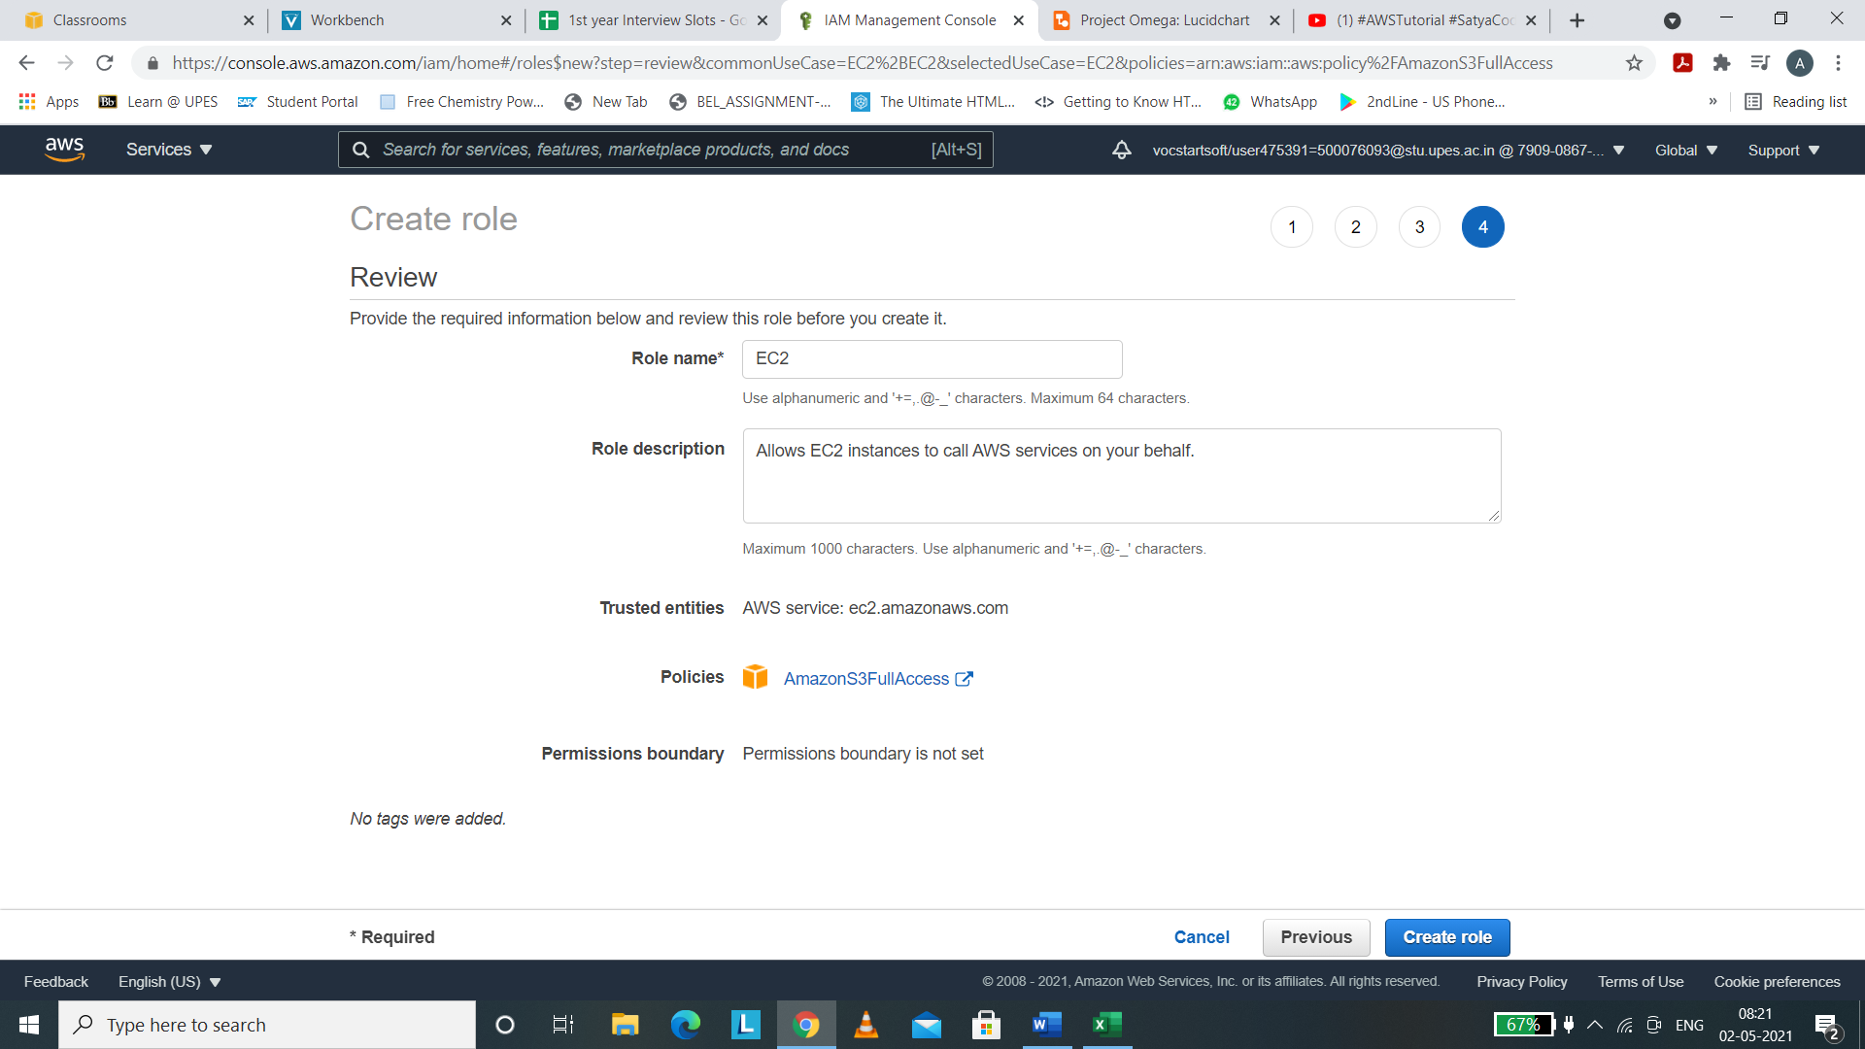

(vi) We can see the role EC2 has been created successfully.

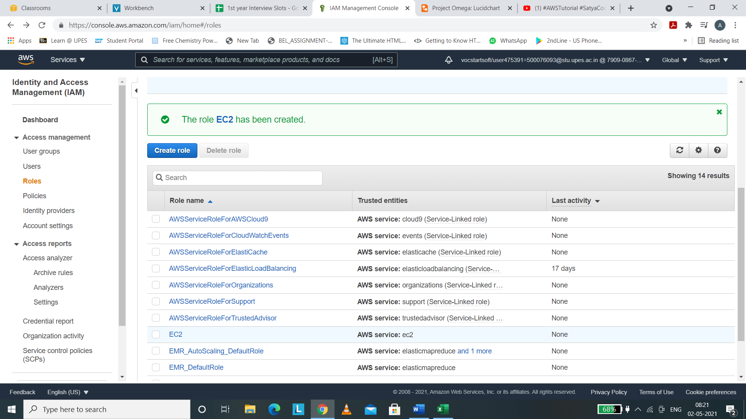

s